BBC Micro:Bit Dice
Let’s make a dice program for our Micro:Bit.
1. Create a new program
2. In the ‘on start’ block, create a start screen that tells you which program is running with either an image or a message.
3. Find the input block for shake:
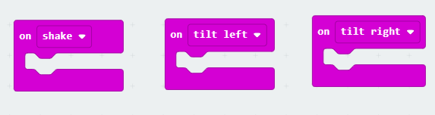
4. We can then put this block which picks a random number:


Inside this one that tells the Micro:Bit to show a number:
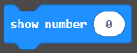

Before moving them into the ‘on shake’ block.
5. At the moment the Micro:Bit will produce any number from 0 to 10. You will need to change this to make it match a normal 6-sided dice.
Now download this to your Micro:Bit for testing.
You can also add sound effects to your dice roll to let the player know it is picking a new number.
Extension:
Can you make this program into a 12-sided dice?
For more of a challenge, how would you make the program act like two 6-sided dice were rolled? Why would this be different to the 12-sided dice program above?
Hint: You will need to use this maths block:
